ReDi School – Project Report

Intro Javascript group 4:

* Sefka Neziri
* Wiktoria Stasiak
* Liliriana Zeqiraj

1. INTRODUCTION AND BACKGROUND

Our learning journey into JavaScript has been one of a kind experience. As a group of individuals with little to no experience in this field we embraced on the challenge that ReDi School gave us. We had to go out of our comfort zone to try something completely new to us and deal with tools we have never used before. Each one of us had an opportunity to act as a leader and link between us and UX/UI group but most importantly we learnt how to work as a group overcoming multiple problems we came across along the way.

1. INTRODUCTION TO JAVASCRIPT

We came into that course with a lot of excitement in us. With limited prior knowledge in programming and using coding programs, understanding the language’s syntax, functions and overall logic was a significant challenge. We had to use a lot of resources outside of the classes itself in order to comprehend tasks given to us by teachers and ultimately being able to create our project – 2 page website for ReDi School.

Rescources we used were:

* Online resources – to better understand the topic we used platforms like freeCodeCamp, W3School, ChatGPT and more. They provided us with a lot of informations and examples but also showcase struggles people had in real life and how to resolve them
* Study group sessions – we had to make sure that everyone is on the same page at all times so we can avoid any unnecessary misunderstandings. On top of that, in order to develop our website we had to collaborate with a group of UX/UI students who designed the page we then coded. During the meetings we shared our knowledge and helped each other with any problems we had at the time. We also simply had fun and got to know each other

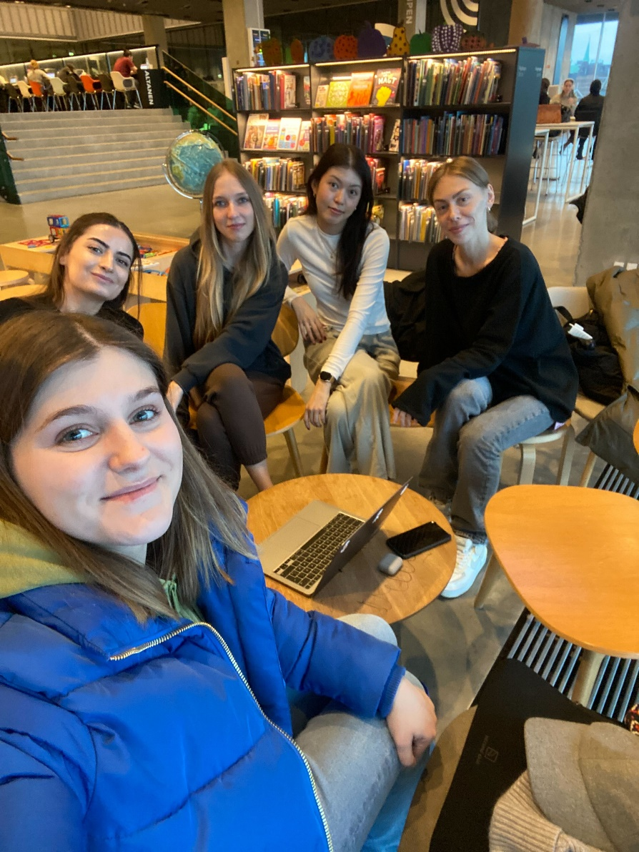

* Real-life exercises – before starting with the website we were given tasks to code small websites on freeCodeCamp which helped us better understand HTML, CSS and JavaScript

1. PROJECT

In order to create the best product possible we had to go through a couple of stages:

* Identifying the need of the stakeholder (ReDI School of Integration Alumni)
* Getting to know what UX/UI group got from the interview with them
* Discussing the design of the website
* Starting the project

After conversation with our stakeholder UX/UI group got a clear image of what they expect of us. That is – a website where people will be able to search and apply for jobs within the field.

Our collaboration with the UX/UI group was extremely important. They were the ones who got to talk with the stakeholder and later on share what they got from the meeting. Along the way we shared feedback and discussed the look of the website which was a crucial part of the project. We had to make sure that their idea is possible for us to execute having that we are all new to the topic.

The tools we used for the project were:

* Visual Studio Code – that’s where the magic happens. That’s the program we learnt and used during classes. We did all of the coding part for the project there
* GitHub – it was a bit complicated learning how GitHub works at first but it was worth it. It’s an amazing platform where we were able to share all of our files
* Google – of course we came across a lot of challenges and things we didn’t know how to solve ourselves yet and google is a very obvious place where we looked for some solutions
* ChatGPT – when google failed we used ChatGPT as our last resort
* Our brains! – a lot of problems we were able to resolve simply by brainstorming and moving our grey cells

We used all sorts of techniques we learnt during classes just like functions, objects and Boolean. Everything the teachers taught us was a valuable source of knowledge and helped us with creating the website.

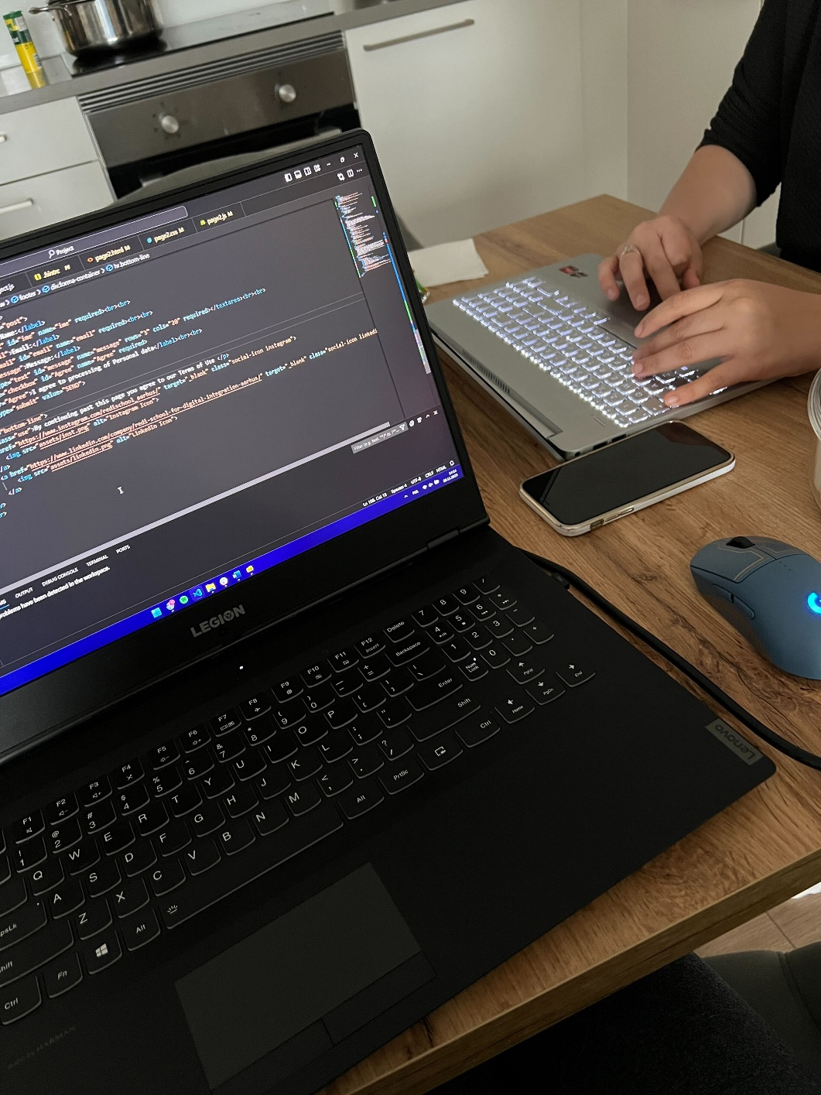

Each one of us spent a significant amount of time learning and working in our free time. The whole process wasn’t easy because we don’t live in the same city and we all have jobs. That meant that regular meetings in person were pretty much impossible having our different schedules. That didn’t stop us though, and we found a way how to work separately from home and share our parts with each other. We quickly discovered that each one of us is better at different things either its JavaScript or HTML and we used that in our project.

1. CONCLUSION

As we mentioned before, we didn’t have any experience with JavaScript before, so it was an amazing opportunity for us to learn how to work with that language (and many others). We had a lot of fun not only getting to know how to code but also to getting to know a lot of wonderful people, make connections and empower each other. We learnt how important having a network in Denmark is and to appreciate each and every connections we make. Practising our organization skills was another thing we got to work on during this semester, being able to connect private life, work and the course was a challenge for all of us but we managed.

ReDi School provided us with an incredible learning opportunity and we’re really happy to be a part of that.